PERIODIC LAW
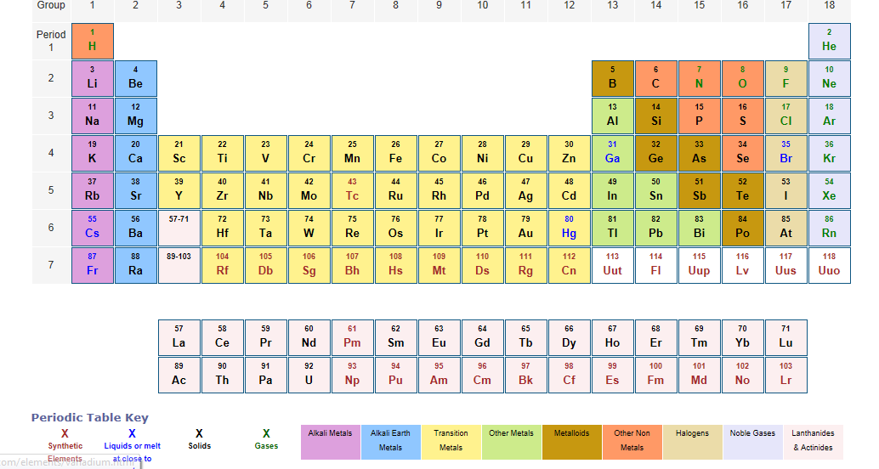
Periodic Table: This shows the arrangement or grouping of elements in order of increasing atomic number.
Periodic Law: Is the basic assumption behind the modern periodic table; it states that the properties of the elements are the periodic function of their atomic number.
Blocks of elements
From the position of the various elements on the periodic table and the electrons arrangements or configuration seem to stand out. Elements that have one and two electron(s) in their last S- orbital i.e. group 1 and 2. S elements are called S block elements P-block elements have their last electron (s) in the P-orbital are called P block element.
Elements that have their last electrons in the d orbital are called d blocks elements while f block elements have their last electrons in the f- orbital.
Moving across a particular period on the periodic table, two elements are present in the S block, six elements in the P block, ten elements in the d- block and fourteen elements in the f- block. This corresponds with the maximum number of electrons in the S, P, D, and F orbitals respectively. Also, S block elements are metals, P block elements are mostly non-metals d- block elements are lanthanides (rare earth metals) and actinides (heavy rare earth metals).
There is therefore a diagonal division of the elements into metals and non-metals as shown below. Metals are found on the left side of the thick boundary line and the non-metals on the right with metalloids occurring along the boundary line.
Families of elements.
Elements are arranged into groups or families and periods. Each group has been given a name to allow proper understanding during discussions on the periodic table.
Names of the different group (1-8) on the periodic table are shown below.
Group (I) i.e. Li, Na, K etc. -------- alkaline metals
Group (II) i.e. Be, Mg, Ca, etc. ------ Alkaline earth metals
Group (III) i.e. B, Al, Ga, etc. ------- Boron family
Group (IV) i.e. C, Si, Ge, etc. --------- Carbon family
Group (V) i.e. N, P, As, etc. ---------- Nitrogen family
Group (VI) i.e. O, S, Se, etc. --------- Oxygen family or challogenes or challones
Group (VII) i.e. Fl, Cl, Br, etc. ------ Halogens
Group (VIII) or group O i.e. He, Ne, Ar, etc. ------ Rare, inert, noble gases.
Transition Elements: These are between groups 2 and 3 on periods 4 and 5.
Lanthanides (Rare- earth elements): these are fifteen elements La- Lu.
Actinides: These are found on the seventh period AC –Lr.
Artificial Elements: These are elements with atomic numbers 93 to 103. They are products formed during chemical reactions. They are unstable and disintegrate in a short time e.g. Plutonium (Pu) and curium (Cm)
Atomic properties and periodic table.
Some properties of the atom change along a group or across a period on the periodic table. Atomic radius which is measured of the size is one of such properties. The orbiting electrons in an atom are best represented by an electron cloud which has no distinct limit as the size of an action cannot be defined easily.
- Atomic radius: This has been defined as the distance of closest approach to another identical atom in a given bonding situation. There are two types of atomic radii. Covalent radius and Van der Waals radius. Covalent radius is half the distance between two identical atoms which are not chemically bonded. For the two types of atomic radius two variations are noticeable:
- The atom radius increases down a group
- The atomic radius decreases along a period.
This is because going down any group on the periodic table the number of valence electrons remains constant while the shells increase in atomic size (radius) despite increase in nuclear charge. The atomic radius of potassium is greater than that of Sodium. The atomic radius of Caesium is greater than that of Rubidium.
Across a period, electrons are added to orbitals in the same shell, all the valence electrons are therefore at the same energy level. As atomic number increase the positive charge of the nucleus increases giving rise to greater attraction between the positive nucleus and negative electrons. This is turn result in contraction of the electrons cloud resulting in a smaller atom. Atomic radii therefore decrease across a given period on the periodic table.
- Ionic Radius: Ions are formed by a loss or gain of electrons by an atom. A positive ion (cation) is smaller than the original metal atom because electrons are pulled in due to increase in effective nuclear charge.
A negative ion (anion) is bigger than the corresponding non- metal atom because the effective nuclear charge is reduced.
As we move across the second short period, the cationic radii decrease from sodium to aluminum while the anionic radii increase from phosphorous to chlorine.
- Ionization energy: Ionization occurs when gaseous atom loses electrons from its outer most shell to become positively charged
K $e^{-} K^{+}$
The energy required to do this is called ionization energy or ionized potential.
First ionization energy of an element is the energy needed to remove one mole of electron(s) from one mole of atoms in the gaseous state. It is expressed in kilo- joules per mole of atoms ionized.
First ionization energy increase across the period with noble gases having the highest. As we go down he the group, the value of first ionization energy decreases. i.e.
FIRST IONIZATION ENERGIES OF ALKALI METALS

Element | LI | Na | K | Rb | Cs
First ionization energy KJMOL⁻¹ | 520 | 500 | 420 | 400 | 380

FIRST IONIZATION ENERGIES OF THE ELEMENTS IN THE THIRD PERIOD OF THE PERIODIC TABLE
Element | Na | Mg | Al | Si | P | S | Cl | Ar
First ionization energy KJMOL⁻¹ | 496 | 737 | 577 | 786 | 1012 | 999 | 1255 | 1521

Three factors that affect the ionization potential of an atom
Ionization potential of an atom is affected by.
- Distance of the outer most electrons from the nucleus.
- Size of the positive or effective nuclear change.
- Screening effect of the inner electrons.
- Electron Affinity: is the energy released when an electron is added to gaseous atom in its lowest energy state. Its unit is KJMOL⁻¹ or electron volts (eV). Electron affinity increase across a period from left to right and decrease down the group on the periodic table.
Group 1 elements, alkali metals have the least tendency to add electrons to their neutral atoms.
Elements in groups VI and VII have greatest tendency to accept electron. Noble gases (group 8 or 0) have stable electronic configuration
DIAGONAL RELATIONSHIP
Because metallic character increases down a group and decreases from left to right along a period, there exists a diagonal relationship between the chemical properties of the first member of a group and that of the second member of the next group as in the cases of lithium and magnesium on one hand, and beryllium and aluminum on the other (see the periodic table)
Li Be B C

Na Mg Al Si

